Founders Day Activity

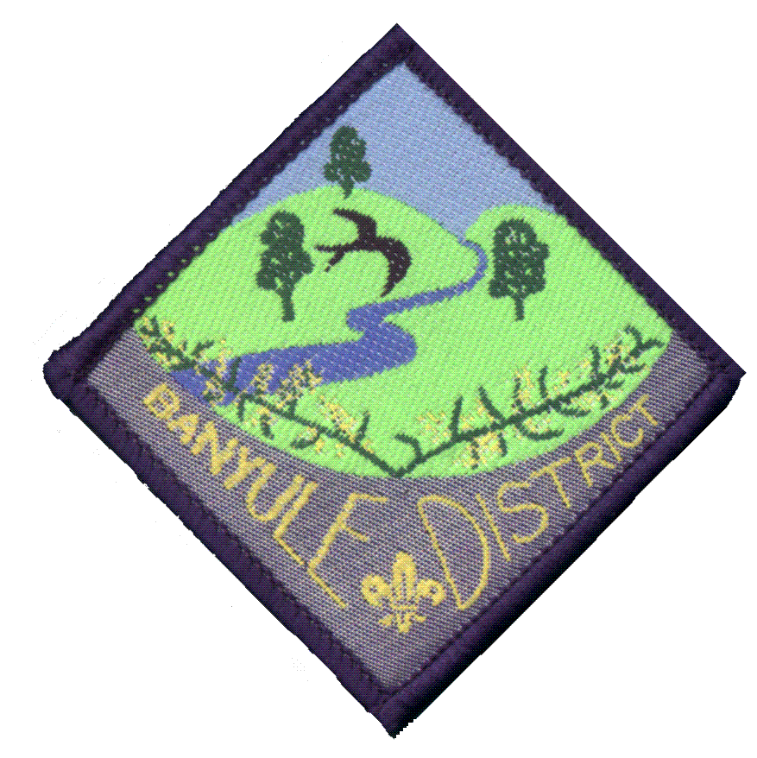
Bike Hike

Sunday, February 20th 10.00AM
Banyule District Cubs Scouts1st Ivanhoe Sea Scouts
Please wear your cub uniform and correct footwear.
Meeting at Banyule Theatre and riding to Wilson Reserve, Irvine Road. Lunch will be served at Wilson Reserve. Pick up time 12.30 p.m.
Lunch Provided
MUST BRING : Bike, Helmet and Full Drink bottle
Starting point:
Banyule Theatre
START
Buckingham Drive, Heidelberg
Melway Ref 32-C4

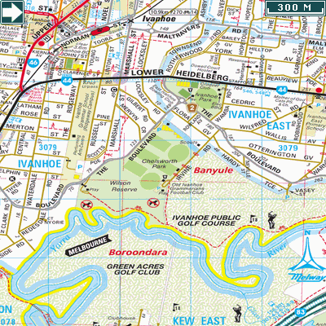

Finishing Point:
Wilsons Reserve, Ivanhoe

Melway Ref 31-G10
BYO Flour Bombs

Contact number for this event
is Wayne Renfrew (Akela) 0411 121 495
…………………………………(tear off)…………………………………………………………………………….…...
PLEASE return to Cubs on Tuesday night:

…………………………………………………………………………………………….….will be attending the Bike Hike and $ 5.00 per person is enclosed

Signed……………………………………(Parent/guardian) Date…………….

